LIFT
A1 Barbell Floor Press (Sets: 3, Reps: 6, Rest: 90s)
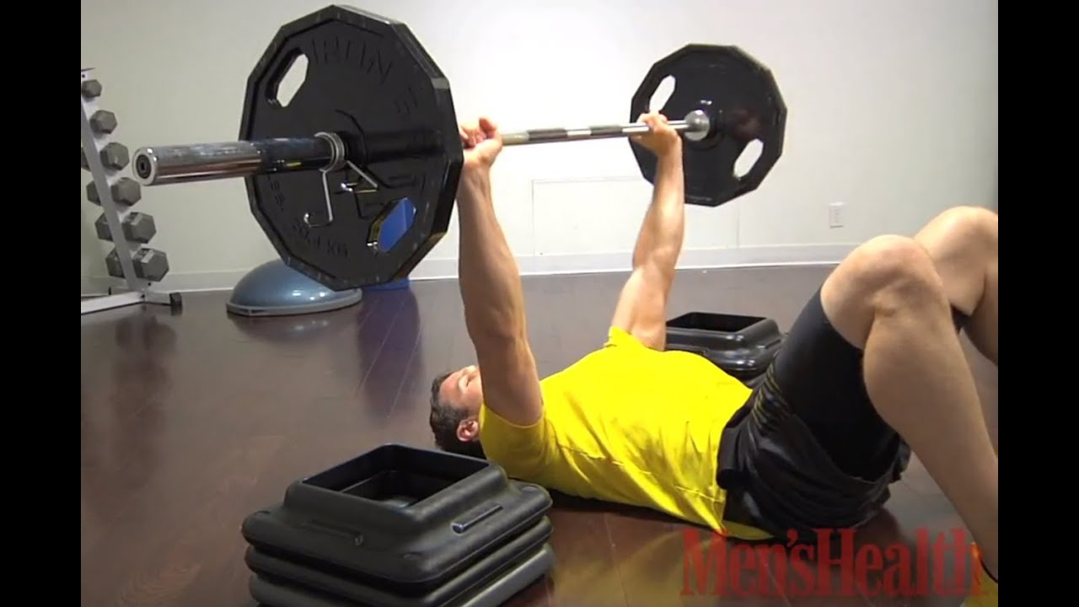
youtube.com
How to Do the Barbell Floor Press - Men's Health
- Lie on the floor holding a barbell above your chest with arms extended.
- Lower the bar to your chest, then press it back up.
A2 DB Offset Squat (Sets: 3, Reps: 8 E/S)
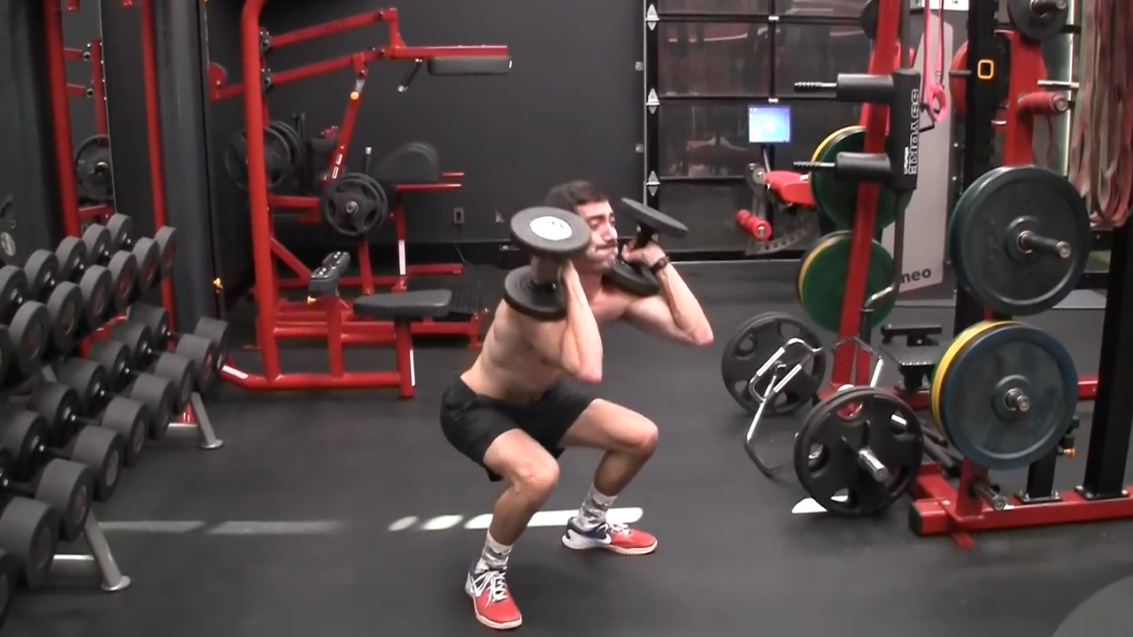
learn.athleanx.com
How To Do The Dumbbell Squat | ATHLEAN-X
- Hold a dumbbell in one hand at shoulder level, feet shoulder-width apart.
- Squat down keeping the weight offset, then stand up. Switch sides.
STRONG
B1 Barbell Incline Row (Sets: 3, Reps: 10)
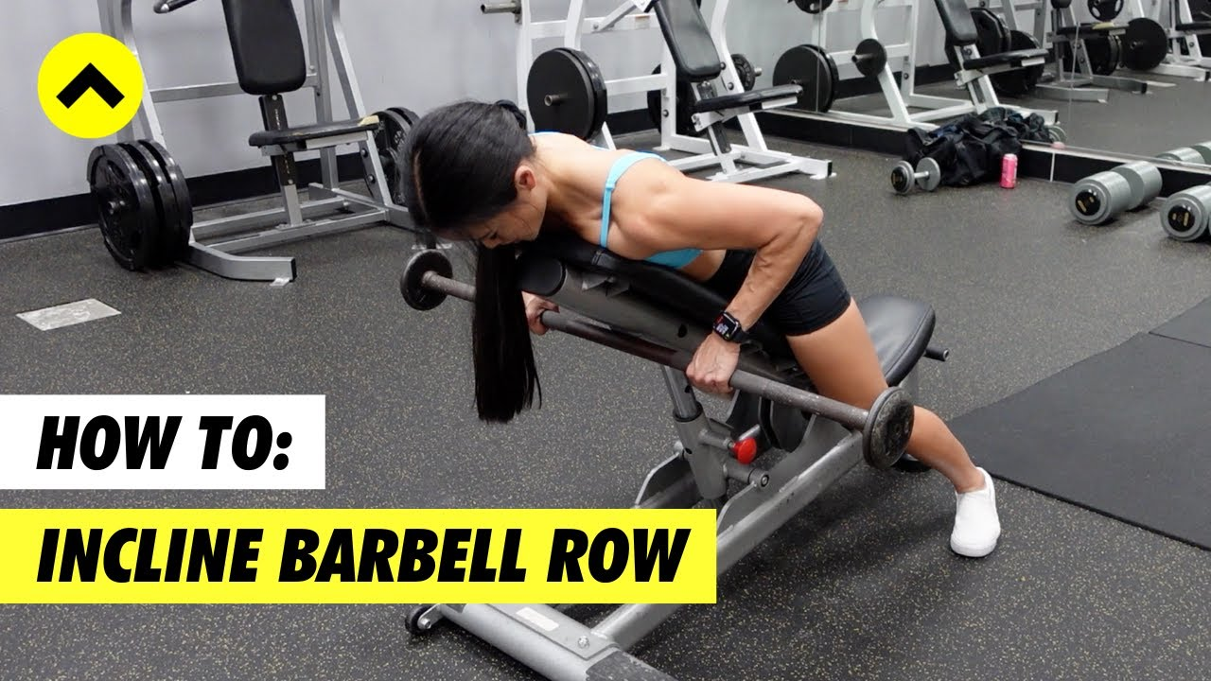
youtube.com
Barbell Incline Row Tutorial | Team Evolve Coaching
- Lie face down on an incline bench, hold barbell below.
- Pull the bar to your chest, squeeze shoulder blades, lower back.
B2 Standing Good Morning (Sets: 3, Reps: 10)
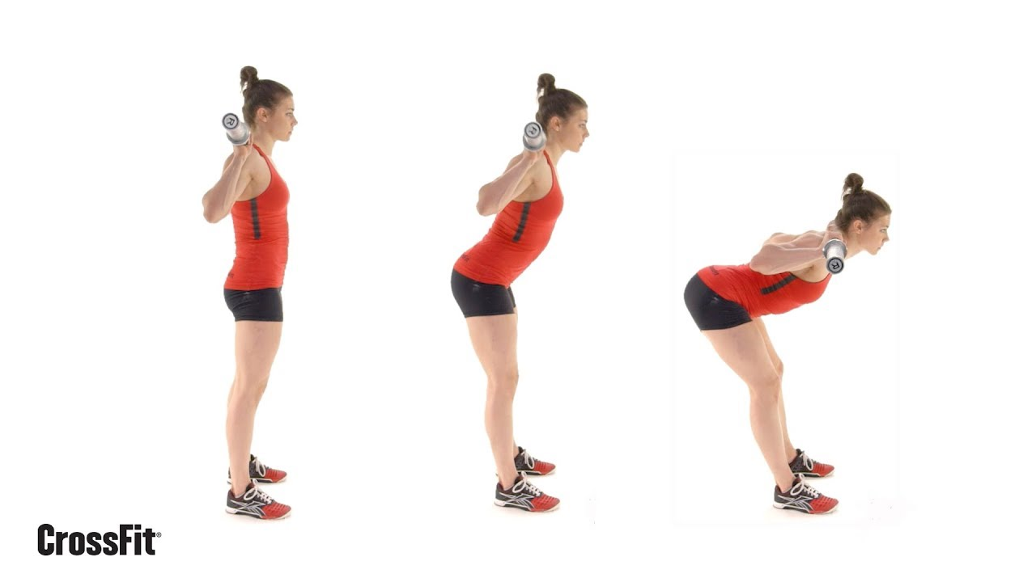
youtube.com
The Good Morning
- Take a Barbell on your back, resting it evenly across your shoulders and the cushioned part of your upper back.
- Stand up straight, push your chest out and hollow your lower back.
- Lean forward from your hips as far as you comfortably can. Keep your chest out and back hollowed.
- Lift back up until your upper body is once again in an upright position.
B3 Banded wood chop (Sets: 3, Reps: 10 E/S)
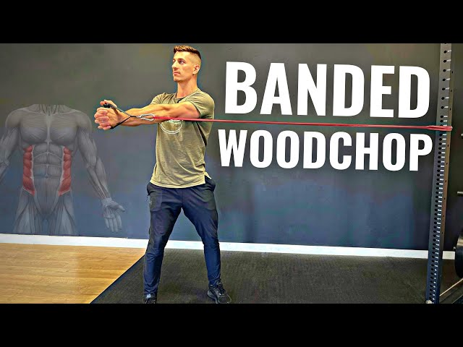
youtube.com
Home Gym RESISTANCE BAND WOOD CHOP and Palov Press - YouTube
- Attach band to high anchor, stand side on.
- Pull band diagonally across body like chopping wood, rotate torso.
UPPER
C1 Standing Barbell Bicep Curl - Medium Grip (Sets: 3-4, Reps: 10, Rest: 60s)
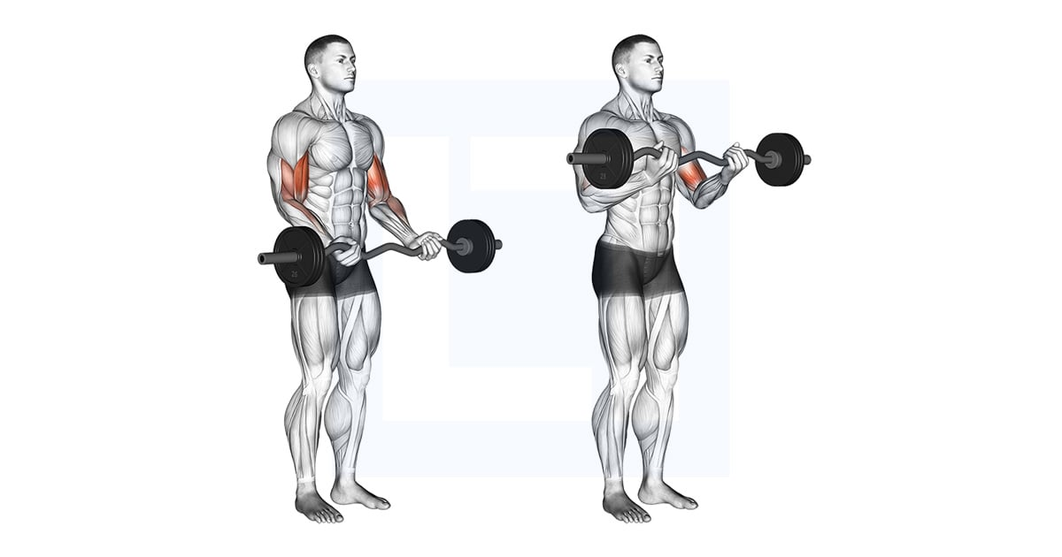
liftmanual.com
Ez Barbell Curl - Guide, Benefits, and Form
- Stand with feet hip width apart. Take the bar with a shoulder width grip and palms facing away from your body.
- Start with elbows straight and your wrists firm.
- Keeping your wrists straight, bend at your elbows until your forearms are in contact with the bulge in your biceps. Don't allow your elbows to come forward in the movement.
- Lower under control back down to the straight arm position.
C2 Lat Pulldown (Sets: 3-4, Reps: 10)
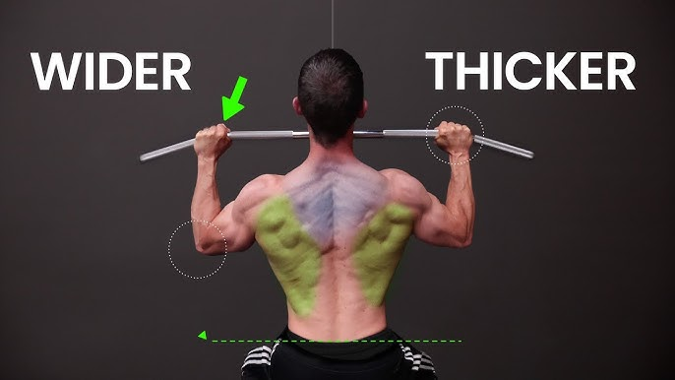
youtube.com
How to do Lat Pulldowns (AVOID MISTAKES!)
- Sit at a lat pulldown station and grab the bar with an overhand grip that's just beyond shoulder width.
- Keep your chest tall and pull the bar down towards your chest.
- Keep your elbows pointed straight down.
- Pull your shoulder blades down and back, as you pull the bar.
- Lower to your chin or just below.
- Pause, then slowly return to the starting position.
LOWER
D1 Weighted Hip Thrust (Sets: 3-4, Reps: 8-12, Rest: 60s)
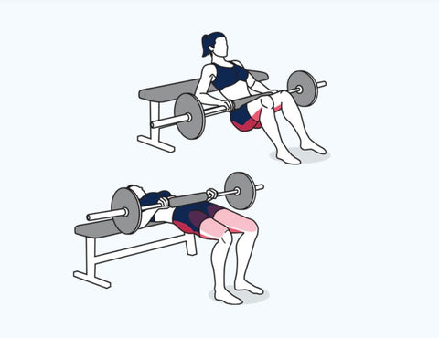
ritfitsports.com
Barbell Hip Thrust Form: How to Build Stronger Glutes Safely
- Load up a barbell with your desired amount of weight and set it on the floor. Take a seat on the floor with your legs underneath the bar, your back should be supported by a bench or an elevated step with your shoulder blades being the point of contact.
- Roll the bar up and over your legs until it is directly above your hips, bend at your knees and walk your feet in towards your glutes.
- Whilst exhaling, squeeze your glutes and drive your heels to lift your hips towards the ceiling. As you do so, lean back over the back support and keep driving upward until your glutes are fully contracted and your body is parallel with the floor.
- Inhale and gently relax your glutes to return the barbell back along the same path to the starting position.
- Repeat for the recommended amount of repetitions. Variation: Barbell Glute Bridge. Variations: Bridge, Hip Thrusts, Barbell Hip Thrusts, Hip Thrusters, Thrusters, Weighted Hip Extension, Barbell Hip Thrusters.
D2 X Band Walk (Sets: 3-4, Reps: 2L)
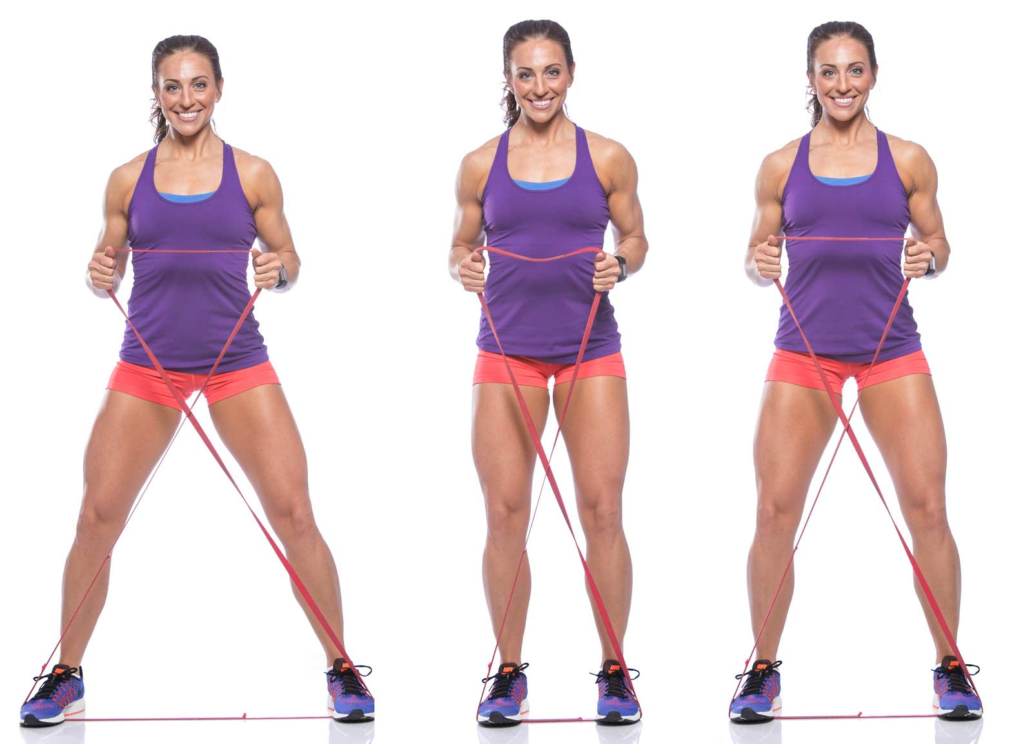
julielohre.com
Lateral Band Walk | X Band Walk... Engage Your Legs with Bands!
- Step on resistance band crossed in X, hold ends.
- Walk sideways keeping tension in the band.
Thursday (04 February)
LIFT
A1 Barbell Split Squat (Sets: 3, Reps: 6 E/S, Rest: 90s)
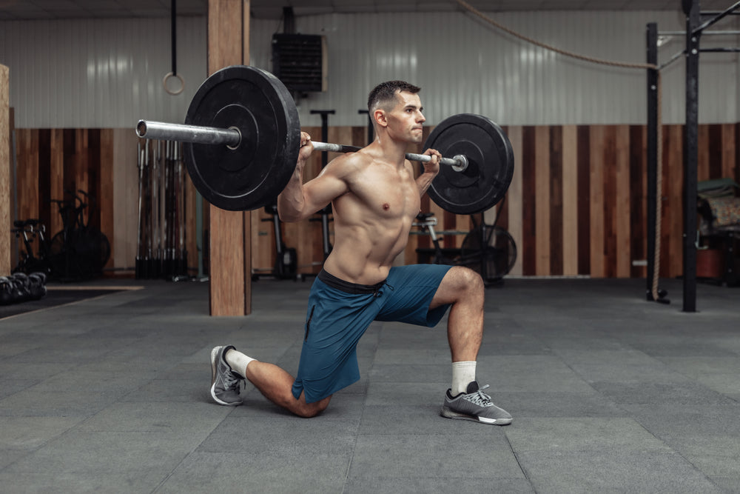
steelsupplements.com
How to Do Barbell Split Squats (Form & Benefits) - Steel Supplements
- Take a barbell on your back, resting it evenly across your shoulders on the cushioned part of your upper back.
- Hold the bar with both hands keeping your elbows directly below your wrists.
- Push your chest up and draw in your tummy with 30% effort. Step forward approximately 1 ½ times your natural stride length.
- Putting your weight on your front leg lower yourself straight down. Keep your front knee behind your toes.
- At the bottom position there should be approximately a 90 degree angle at the back of both knees. Your back heel should come off the ground.
- Push back up with your weight coming through your front foot. Your feet should remain in the same position through all repetitions of the exercise.
- Keep your head and chest upright with your hips level and forward facing during the whole movement.
A2 3 Point row (Sets: 3, Reps: 8 E/S)
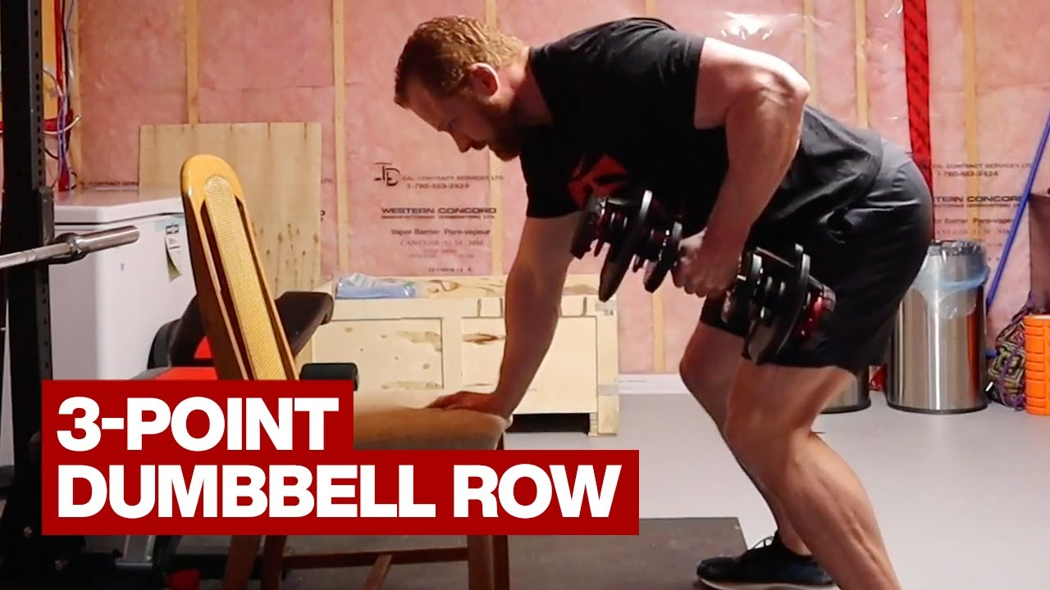
youtube.com
3-Point Dumbbell Row
- Place one hand and knee on bench, other foot on floor, hold dumbbell in free hand.
- Row the dumbbell up to your side, then lower.
STRONG
B1 Glute Bridge (Sets: 4, Reps: 8, Intensity: EMOM)
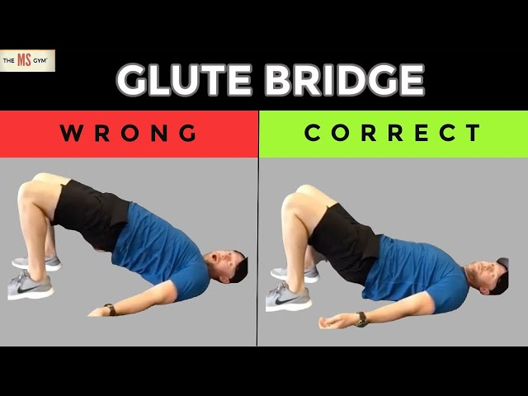
youtube.com
HOW TO DO A HIP BRIDGE CORRECTLY USING YOUR GLUTES - YouTube
- Lie face up on a mat.
- Bend your knees so your feet are flat on the floor with heels under knees.
- Push through your heels, lifting your hips up to the point where there is a straight line from your chest to your knees. Squeeze your bum at the top of the movement.
- Lower until your bum is just above the ground and lift again.
- Keep your hips aligned throughout the whole movement.
B2 45° Incline Dumbbell Chest Press - Pronated Grip (Sets: 4, Reps: 8)
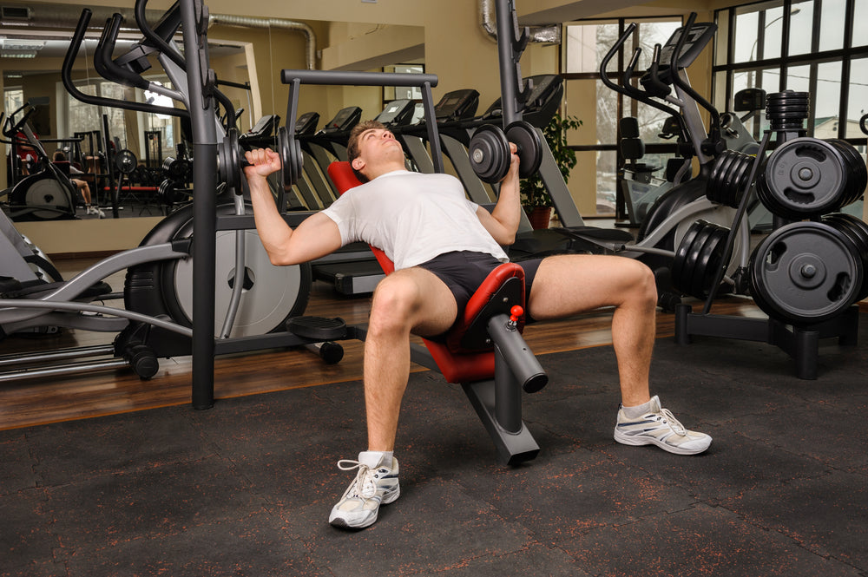
steelsupplements.com
How To Do Incline Dumbbell Presses (Form & Benefits) - Steel ...
- Lie face up on a 45° inclined bench with a dumbbell in each hand and palms facing your feet.
- Start in the bottom position and extend your arms bringing your hands in front of your shoulders with elbows straight.
- Lower back down under control to a position just outside your body and as low as you can go before pushing back up again.
- Keep your bum, back and head in contact with the bench at all times.
B3 Plank (Sets: 4, Reps: 40s)
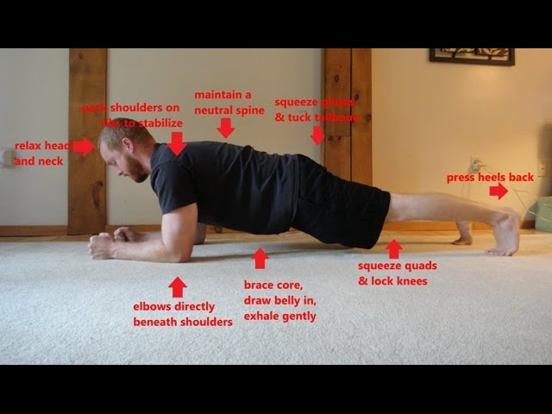
youtube.com
How to do a Plank: 1 Minute Summary of Proper Plank Form - YouTube
- Come down so that your elbows, feet and hands are touching the floor.
- Engage your core by drawing your tummy in and pelvic floor (the muscle you would use to stop yourself from peeing) up with 30% effort.
- Keep your bum down so your body is flat from your ankles to your head.
- Hold.
UPPER
C1 Bench Press - Narrow Grip (Sets: 4, Reps: 15, 12, 9, 6)
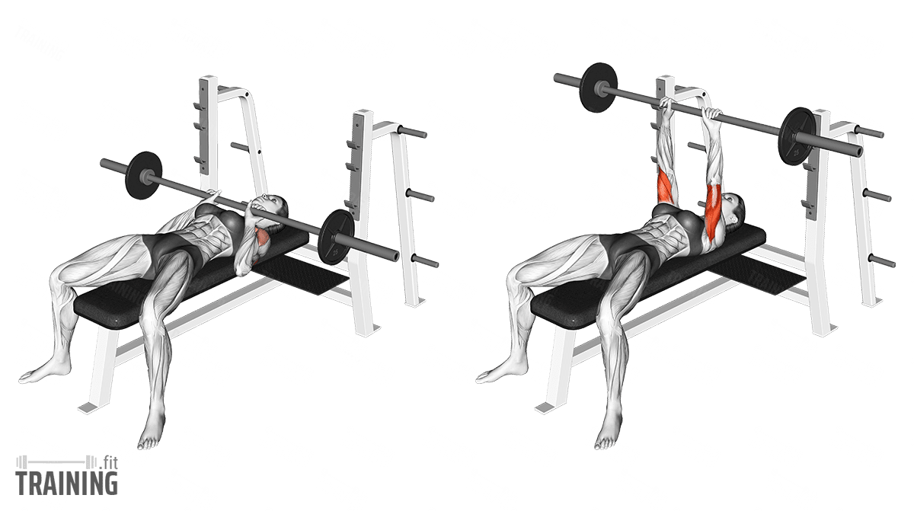
training.fit
Close-Grip Bench Press - Instructions, Information & Alternatives ...
- Lie face up on a bench; Take the bar with your hands roughly 2 thumbs apart and palms facing away from your head.
- Start with arms straight above your chest.
- Lower under control until the bar touches your chest. Keep your elbows close to your body.
- Keeping your bum, back and head in contact with the bench, push the bar back up to the start position.
C2 DB Tricep Roll Backs (Sets: 4, Reps: 15, 12, 9, 6)
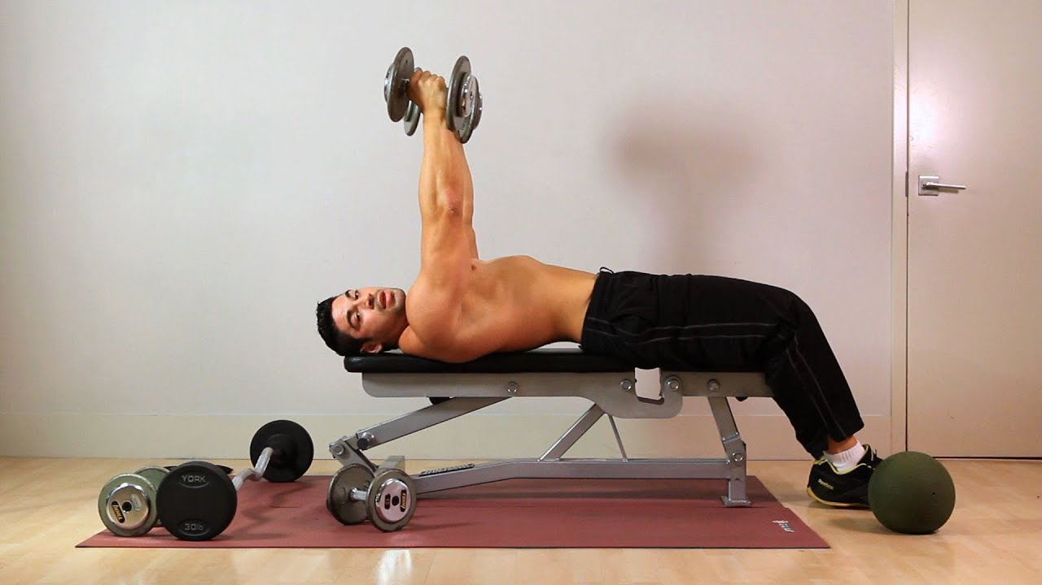
youtube.com
How to Do a Rolling Dumbbell Extension | Arm Workout
- Lie on bench, hold dumbbells above chest, palms facing.
- Lower forearms back keeping upper arms fixed, then extend.
LOWER
D1 Goblet Squat 1.5 (Sets: 4, Reps: 15, 12, 9, 6, Rest: 60s)
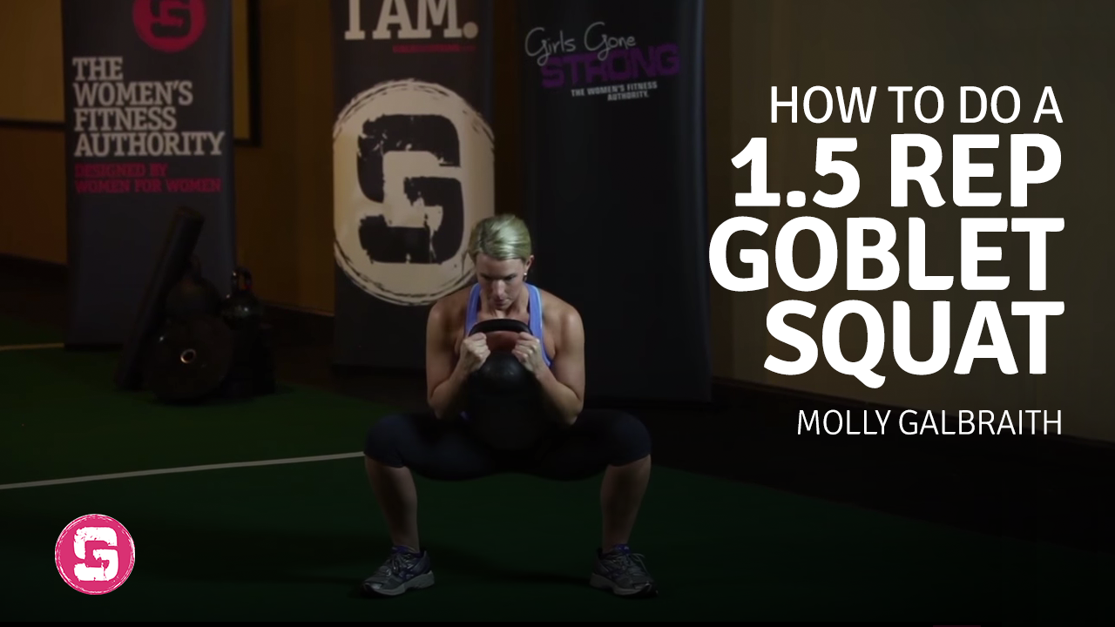
girlsgonestrong.com
1.5 Rep Goblet Squat - Kettlebell Workout
- Hold dumbbell at chest, squat down fully.
- Come halfway up, squat down again, then fully up. That's one rep.
D2 Low Walking Lunges (Sets: 4, Reps: 15, 12, 9, 6)
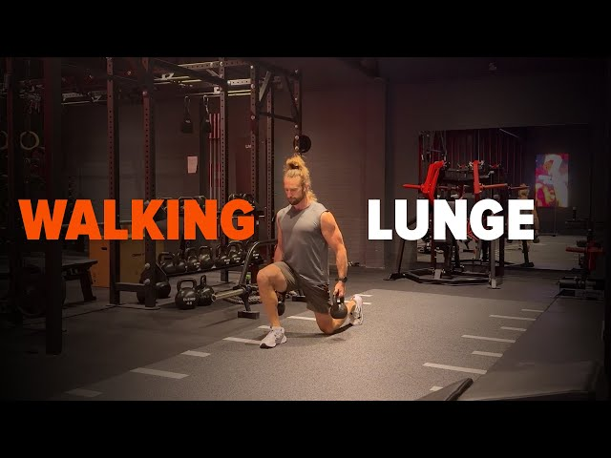
youtube.com
Walking Lunge | Proper Form Tutorial for Legs & Glutes - YouTube
- Take a step forward into lunge, lower until back knee almost touches ground.
- Push forward to next lunge, alternate legs.
Saturday (06 February)
LIFT
A1 trap bar rdl (Sets: 3, Reps: 6, Rest: 90s)
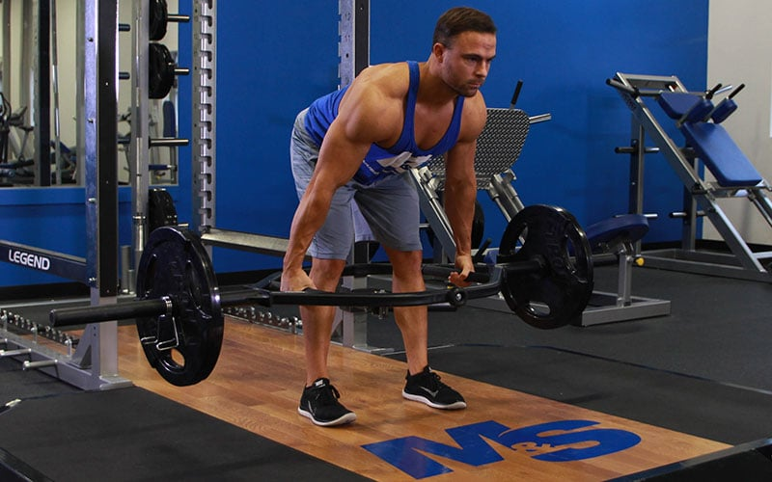
muscleandstrength.com
Trap Bar Romanian Deadlift
- Stand in trap bar, grip handles.
- Hinge at hips to lower bar, keep back straight, then stand up by driving hips forward.
A2 ring press up (Sets: 3, Reps: 8-12)
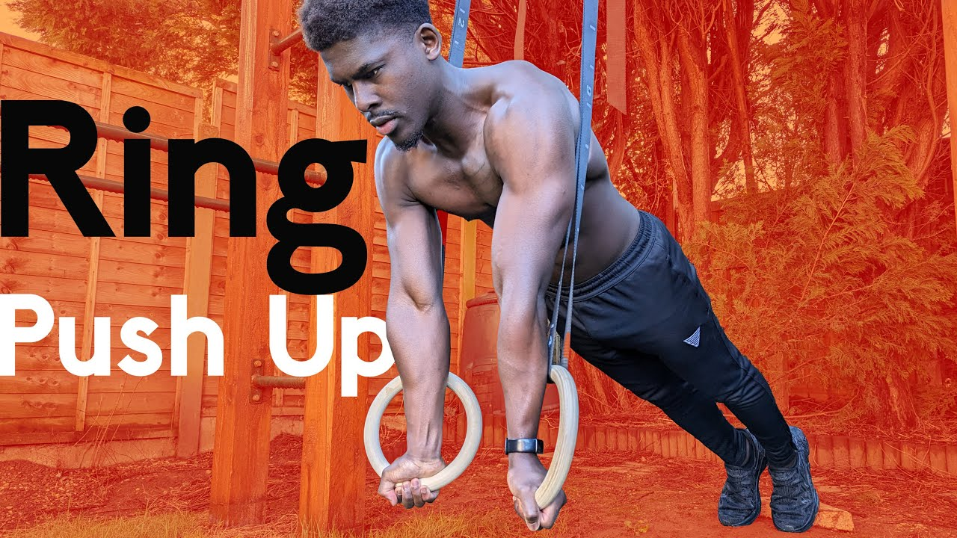
youtube.com
Ring Push Up Tutorial | Do It Right
- On gymnastic rings, lower chest to rings.
- Push back up to straight arms.
STRONG
B1 Split Squat (Sets: 3, Reps: 10, Rest: 60s, Intensity: FFE)

liveleantv.com
Split Squat Form, Muscles Worked, Variations For Glutes & Quad
- Stand in split stance, lower back knee to ground.
- Push up through front foot.
B2 Pull Up (Sets: 3, Reps: 10)
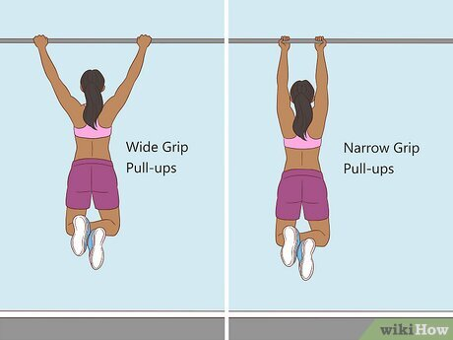
wikihow.com
How to Do Pullups: Proper Form, Variations, & Training Plan
- Stand under the chin up bar at a height where you are able to grip the bar without jumping.
- Take hold of the bar with both hands facing away from you and shoulder width apart. Bring your shoulder blades back towards each other and down towards your bum.
- Pull yourself up to the top position. Your chin should be above your hands and chest pushed out.
- From the top position, lower yourself down under control to the bottom.
B3 Hammer Floor Press (Sets: 3, Reps: 10, Intensity: Neutral)
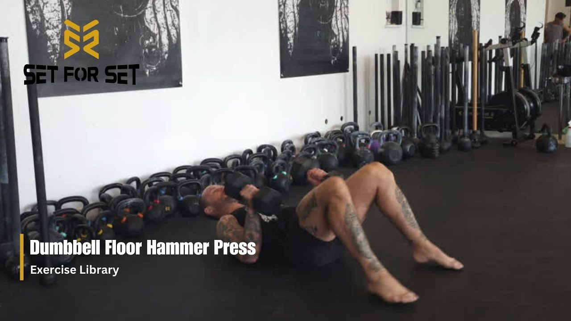
youtube.com
Dumbbell Floor Hammer Press | SFS Exercise Library
- Lie on floor, hold dumbbells with neutral grip above chest.
- Lower to sides, then press up.
UPPER
C1 Plate Front Raise (Sets: 2-3, Reps: 8-6-MAX, Rest: 60s)
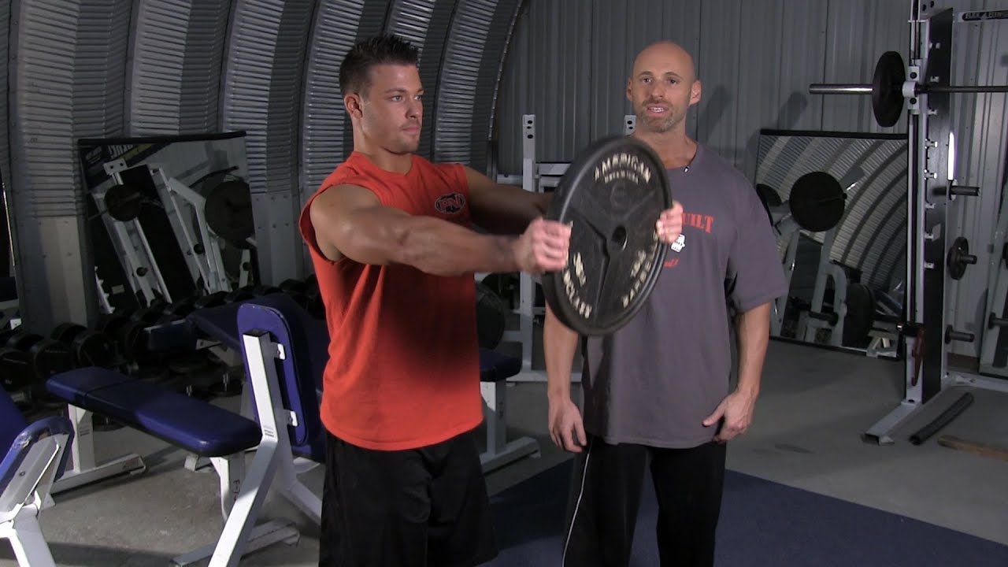
youtube.com
Front Plate Raise
- Hold weight plate with both hands in front.
- Raise straight arms to shoulder height, then lower.
C2 DB Rear Fly (Sets: 2-3, Reps: 8-6-MAX)
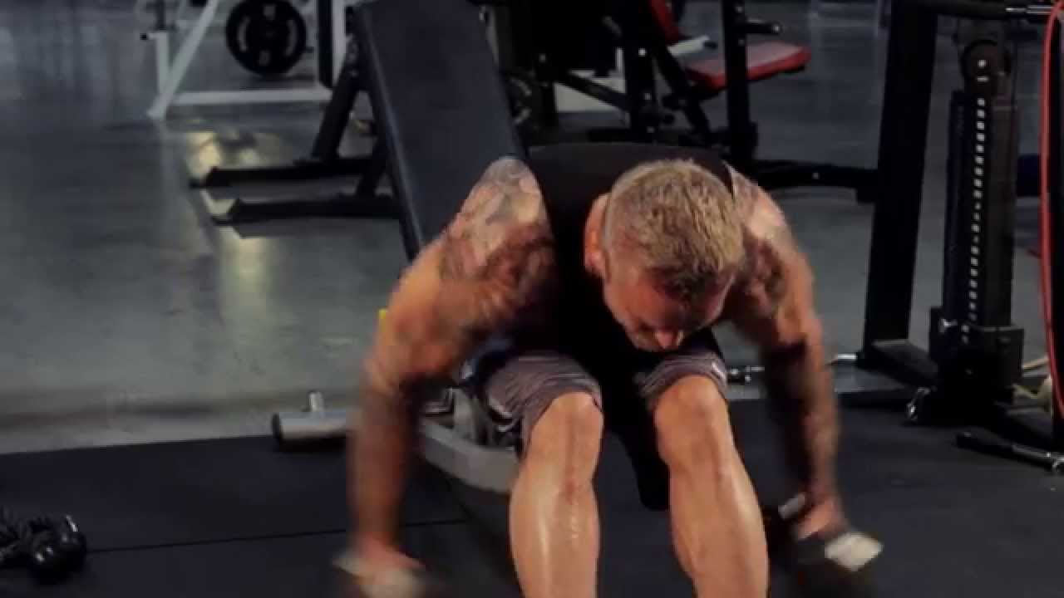
youtube.com
Dumbbell Rear Delt Flye - The Proper Lift - BPI Sports
- Bend over, hold dumbbells.
- Raise arms out to sides squeezing rear delts, then lower.
LOWER
D1 Sprinters Bridge (Sets: 3-4, Reps: 12)
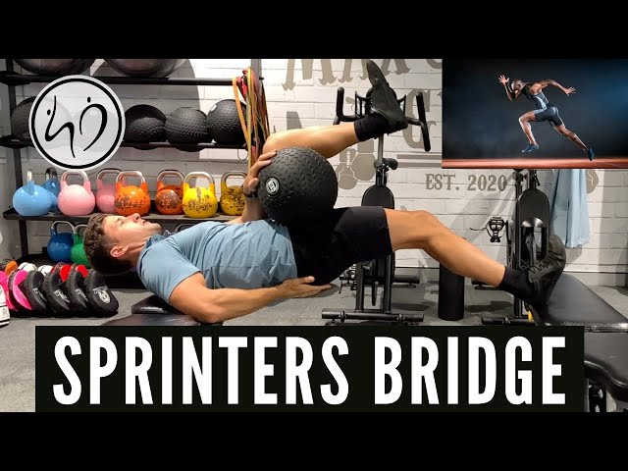
youtube.com
Improve running technique with the Sprinter's Bridge - YouTube
- Lie on back, one knee bent with foot flat, other leg extended.
- Lift hips high, squeeze glute of bent leg.
D2 Banded Lying leg Curl (Sets: 3-4, Reps: 12)
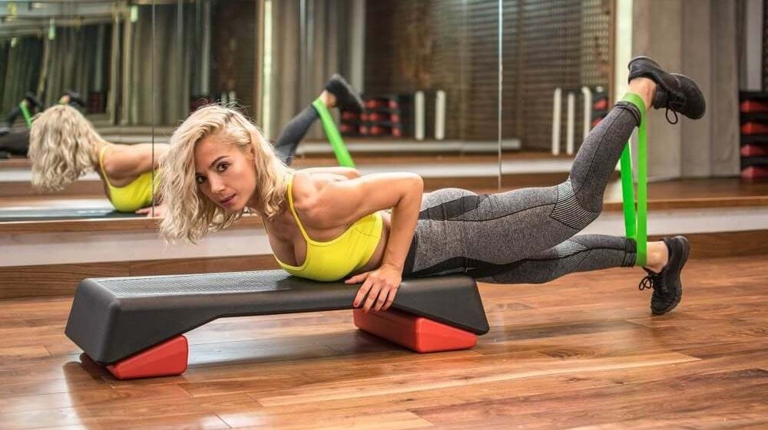
puregym.com
How To Do Banded Hamstring Curls | PureGym
- Lie prone, band around ankles anchored behind.
- Curl heels to butt against band resistance.

